**Kubeadm Installation & Minikube installation**

# Minimum server requirements for K8s Installation  
1. Master – t2.large (2 vCPU 8 GiB Memory)  
2. Worker node 1&2 - t2.large (2 vCPU 8 GiB Memory)  
  
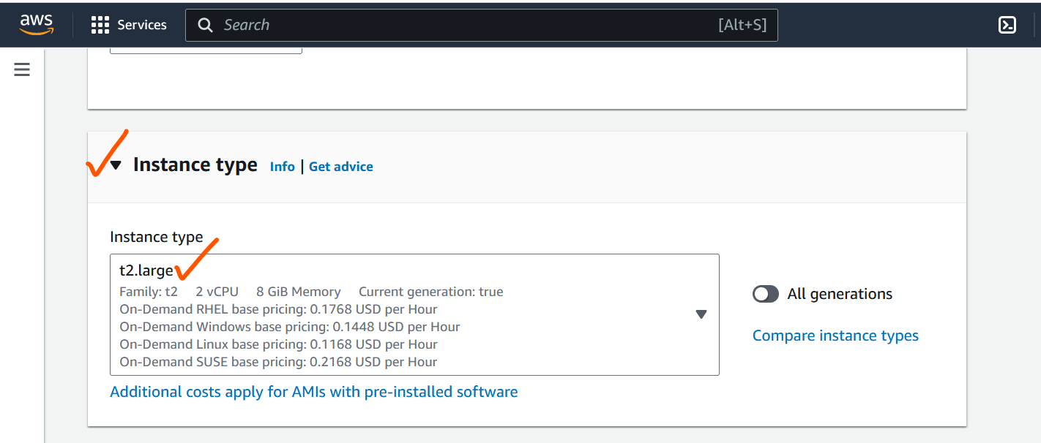

**1. Install Docker**

# yum -y install docker

-> Install docker on Master and worker nodes   
/ Execute all below commands in workernodes as well

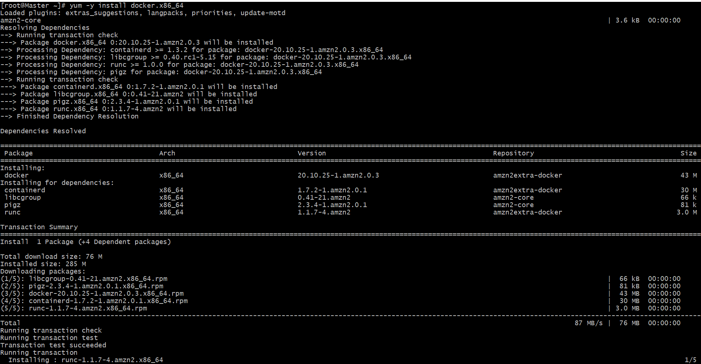

2.

# docker --version



3.

# systemctl start docker

# systemctl status docker

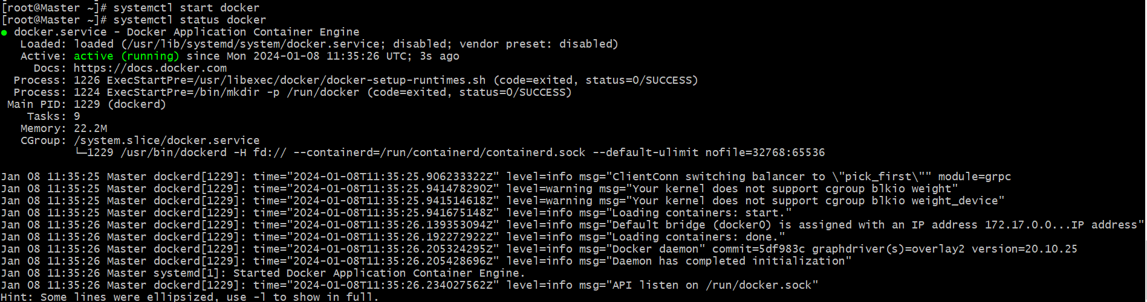

@ To setup k8s cluster we have different tools like kops and kubeadm. / Below mentioned the Google chrome installation path / After open the chrome page -> Select the OS type -> Like Redhat.

* https://kubernetes.io/docs/setup/production-environment/tools/kubeadm/install-kubeadm/

4. sudo sed -i 's/^SELINUX=enforcing$/SELINUX=permissive/' /etc/selinux/config



5. vi /etc/yum.repos.d/kubernetes.repo



--> Place this script in this mentioned path in Master & Worker nodes -->

6. vi /etc/yum.repos.d/kubernetes.repo  
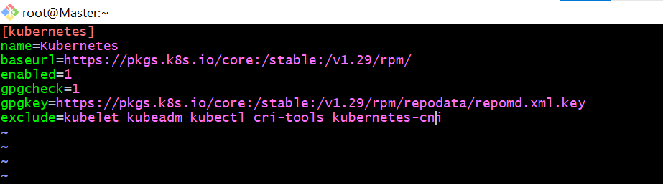

[kubernetes]

name=Kubernetes

baseurl=https://pkgs.k8s.io/core:/stable:/v1.29/rpm/

enabled=1

gpgcheck=1

gpgkey=https://pkgs.k8s.io/core:/stable:/v1.29/rpm/repodata/repomd.xml.key

exclude=kubelet kubeadm kubectl cri-tools kubernetes-cni

* For installation execute the below command

7. sudo yum install -y kubelet kubeadm kubectl --disableexcludes=kubernetes --disableplugin=priorities

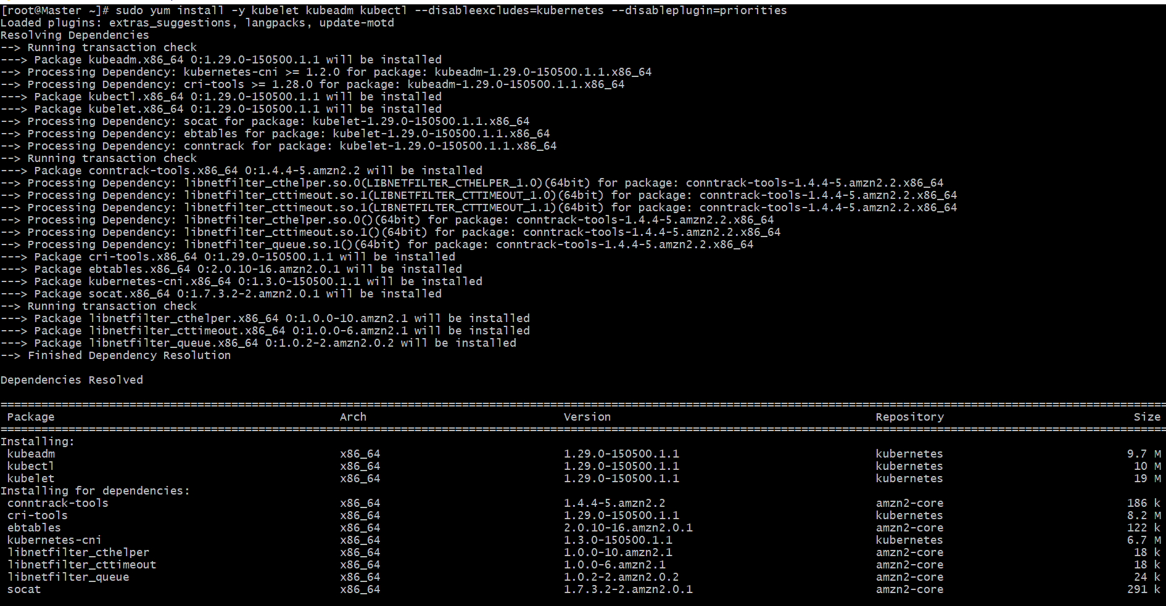

After executed Below command we will get some commands to execute / Mentioned Below

Note: Only master node will get the commands to execute in the workernodes

8. kubeadm init --pod-network-cidr=10.244.0.0/16

Note: We need to execute this command only in Master node

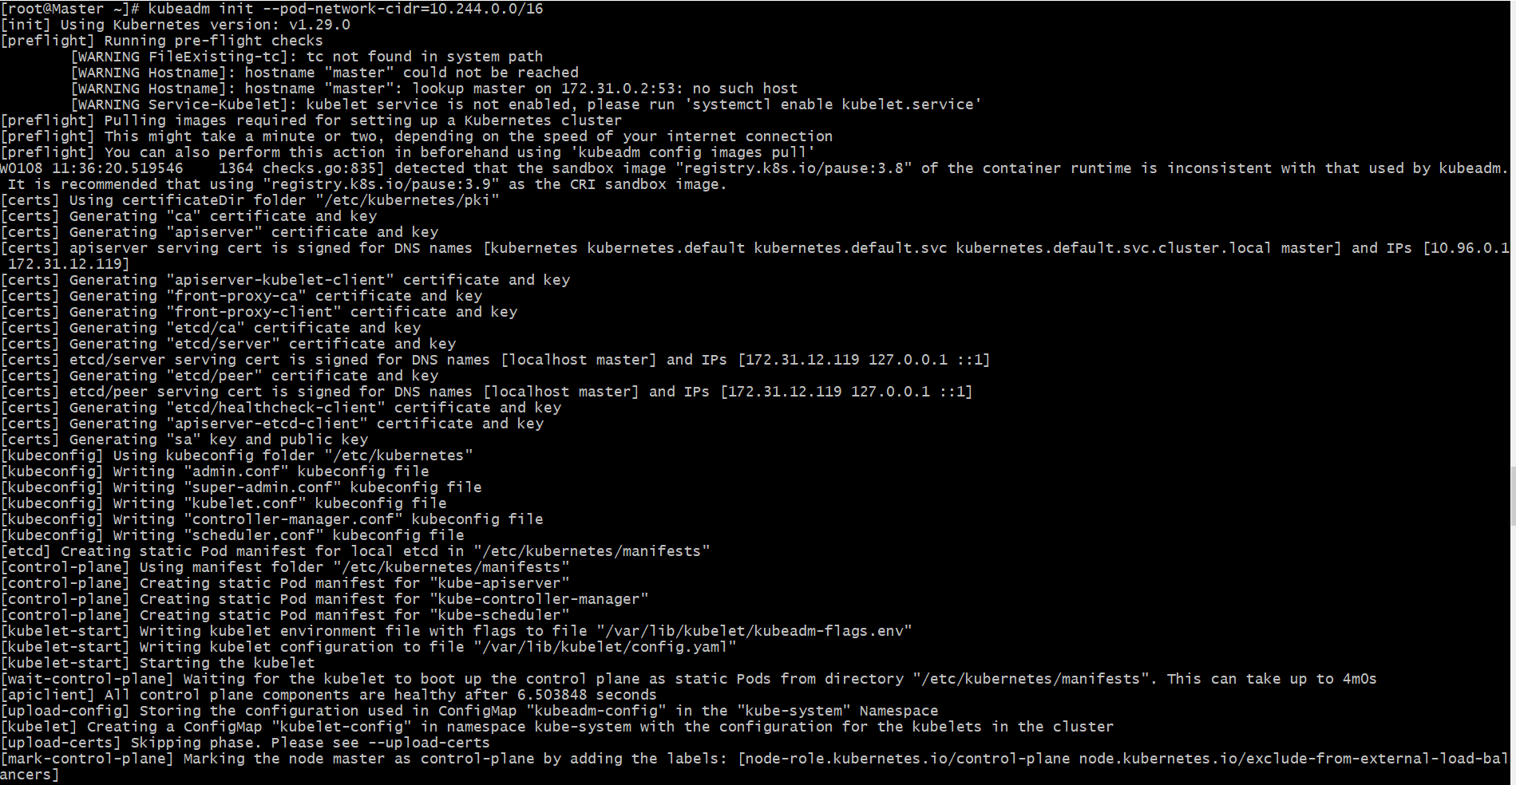

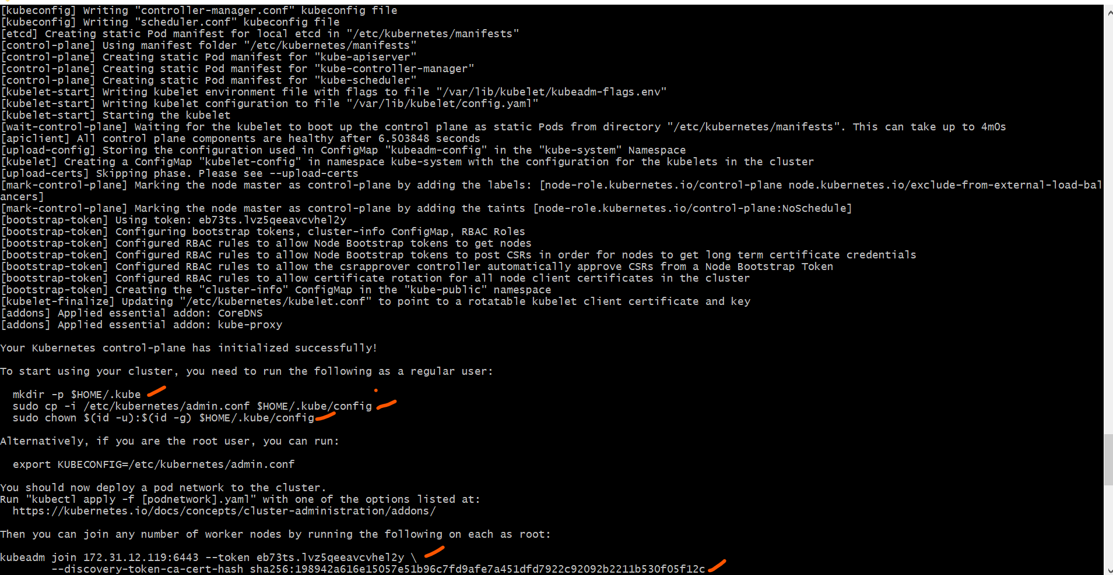

9. mkdir -p $HOME/.kube

10.sudo cp -i /etc/kubernetes/admin.conf $HOME/.kube/config

11.sudo chown $(id -u):$(id -g) $HOME/.kube/config

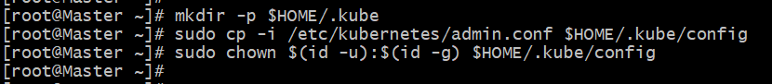

@ Execute this command in worker nodes. (Execute the master node to worker nodes)

12. kubeadm join 172.31.12.119:6443 --token eb73ts.lvz5qeeavcvhel2y \

--discovery-token-ca-cert-hash sha256:198942a616e15057e51b96c7fd9afe7a451dfd7922c92092b2211b530f05f12c

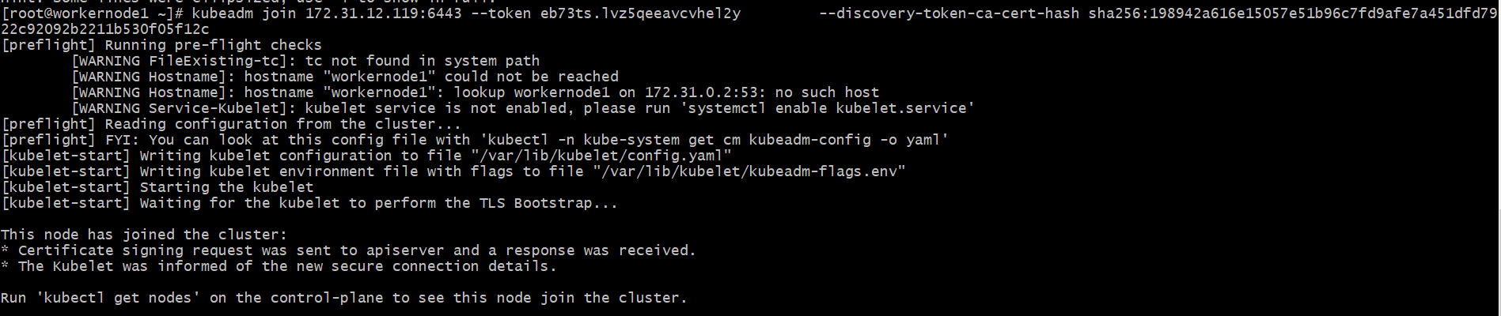

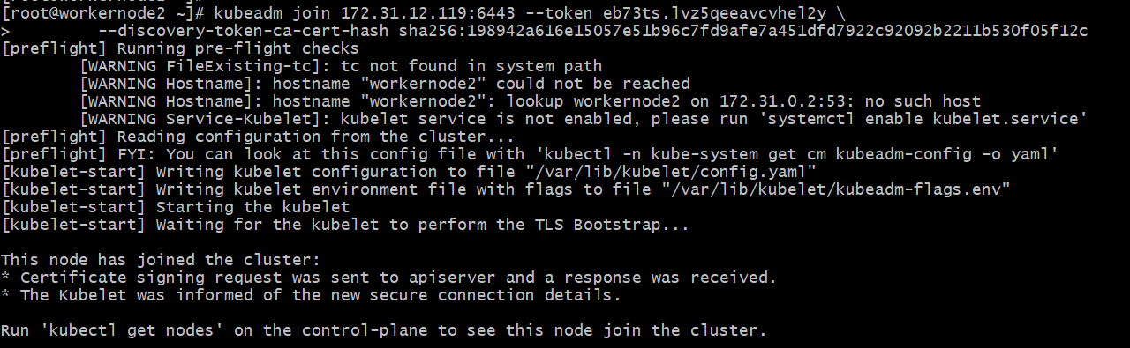

If we execute kubectl get nodes we can see the status as notready because we haven't installed flannel

13. kubectl get nodes

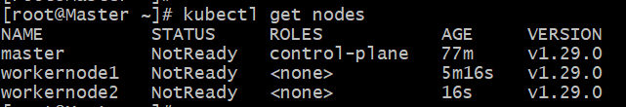

# Flannel is installed  
  
kubectl apply -f https://github.com/flannel-io/flannel/releases/latest/download/kube-flannel.yml

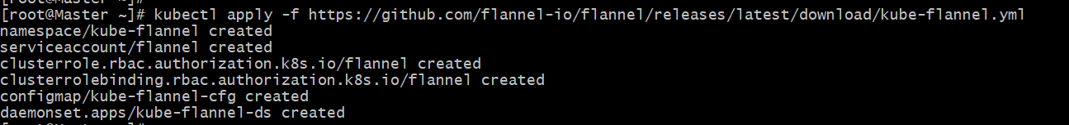

# Now Master and Worker nodes are ready

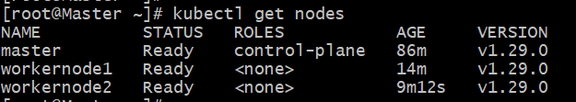  
  
  
############################################################################  
  
  
  
  
  
**Minikube installation on Windows**  
Minikube:

========

Minikube is a single cluster with all k8s component.

minikube is used for learning and development purposes.

Install minikube on windows:

===========================

1) Install Docker on windows.

https://docs.docker.com/desktop/install/windows-install/

2) Install Oracle box on windows

https://adamtheautomator.com/install-virtualbox-on-windows-10/

3) Check system info in CMD

systeminfo

4) Install Minikube using powershell

https://minikube.sigs.k8s.io/docs/start/

5) Set the minikube path to environmental varaible

6) Restart powershell and start minikube

minikube start

To check minikube ip use : minikube ip

To ssh to minikube: minikube ssh

To connect or check the pods : kubectl get pods

To see minikube on dashboard: minikube dashboard  
  
  
  
  
# https://docs.docker.com/desktop/install/windows-install/

1. Install docker desktop on windows  
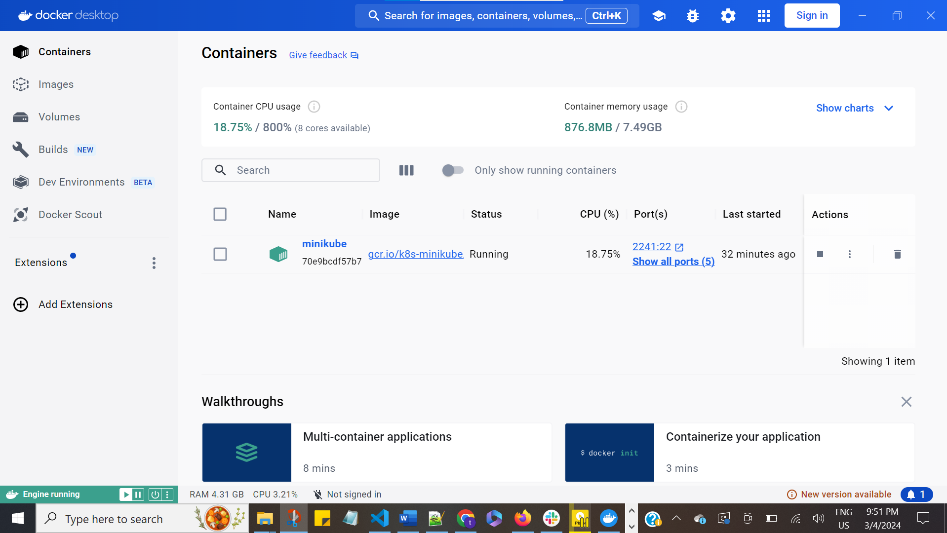  
  
  
2. Check the docker version in the local / After docker desktop installation then only docker version will be shown in the git cli  
  
# docker --version  
  
 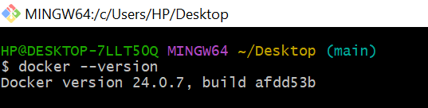  
  
3. Go to this path for doenload the minikube installation commands  
  
# https://minikube.sigs.k8s.io/docs/start/  
  
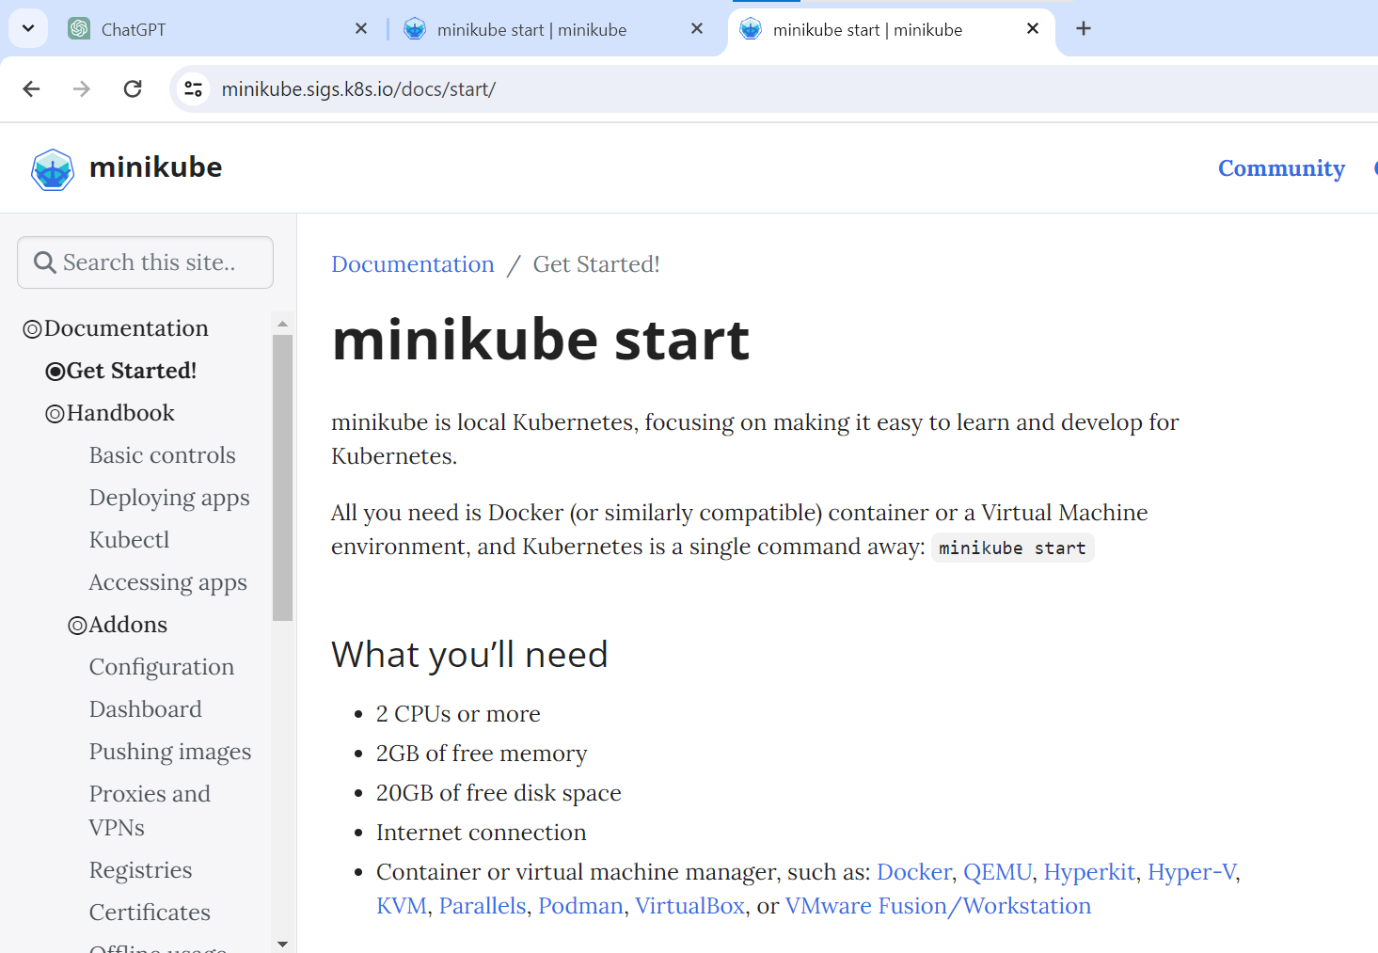  
  
  
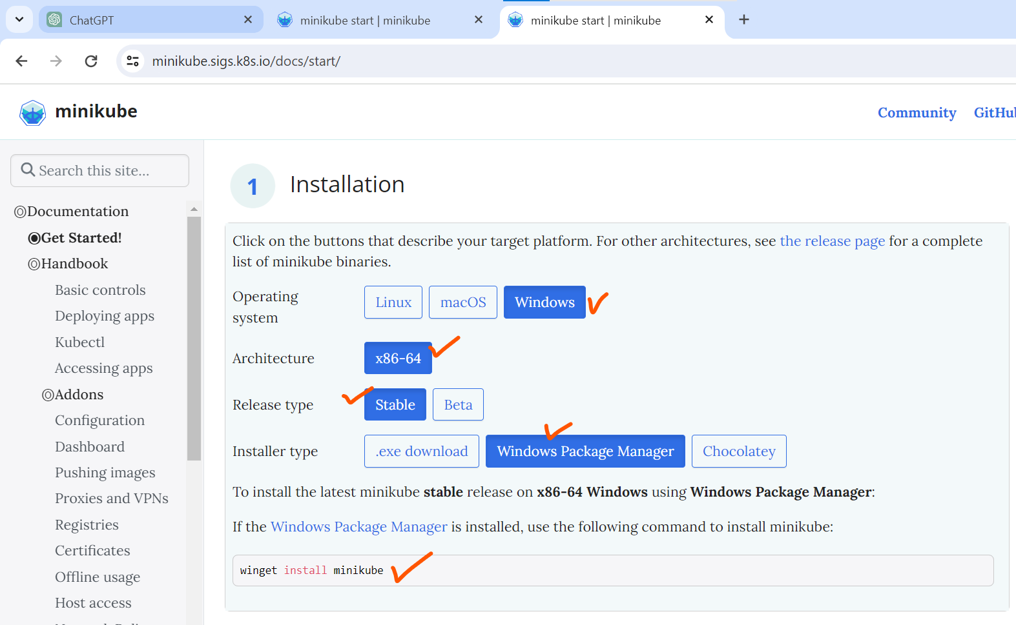  
# winget install minikube  
  
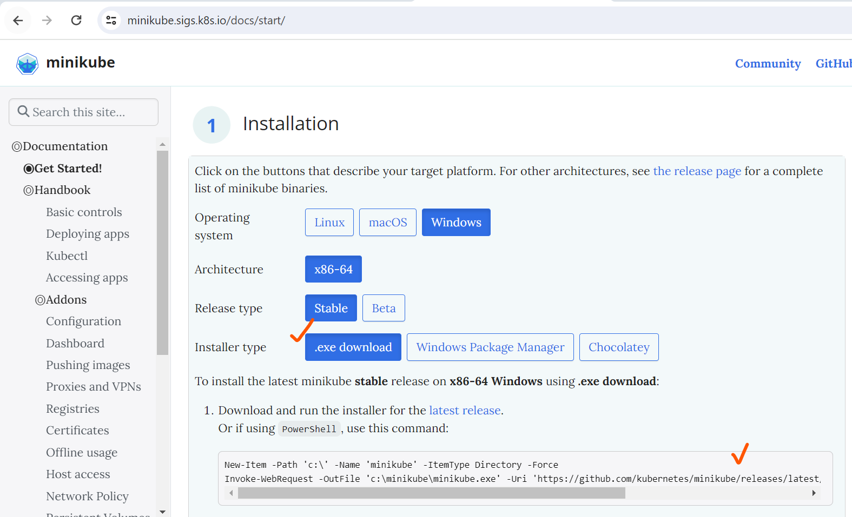

# New-Item -Path 'c:\' -Name 'minikube' -ItemType Directory -Force

Invoke-WebRequest -OutFile 'c:\minikube\minikube.exe' -Uri 'https://github.com/kubernetes/minikube/releases/latest/download/minikube-windows-amd64.exe' -UseBasicParsing  
  
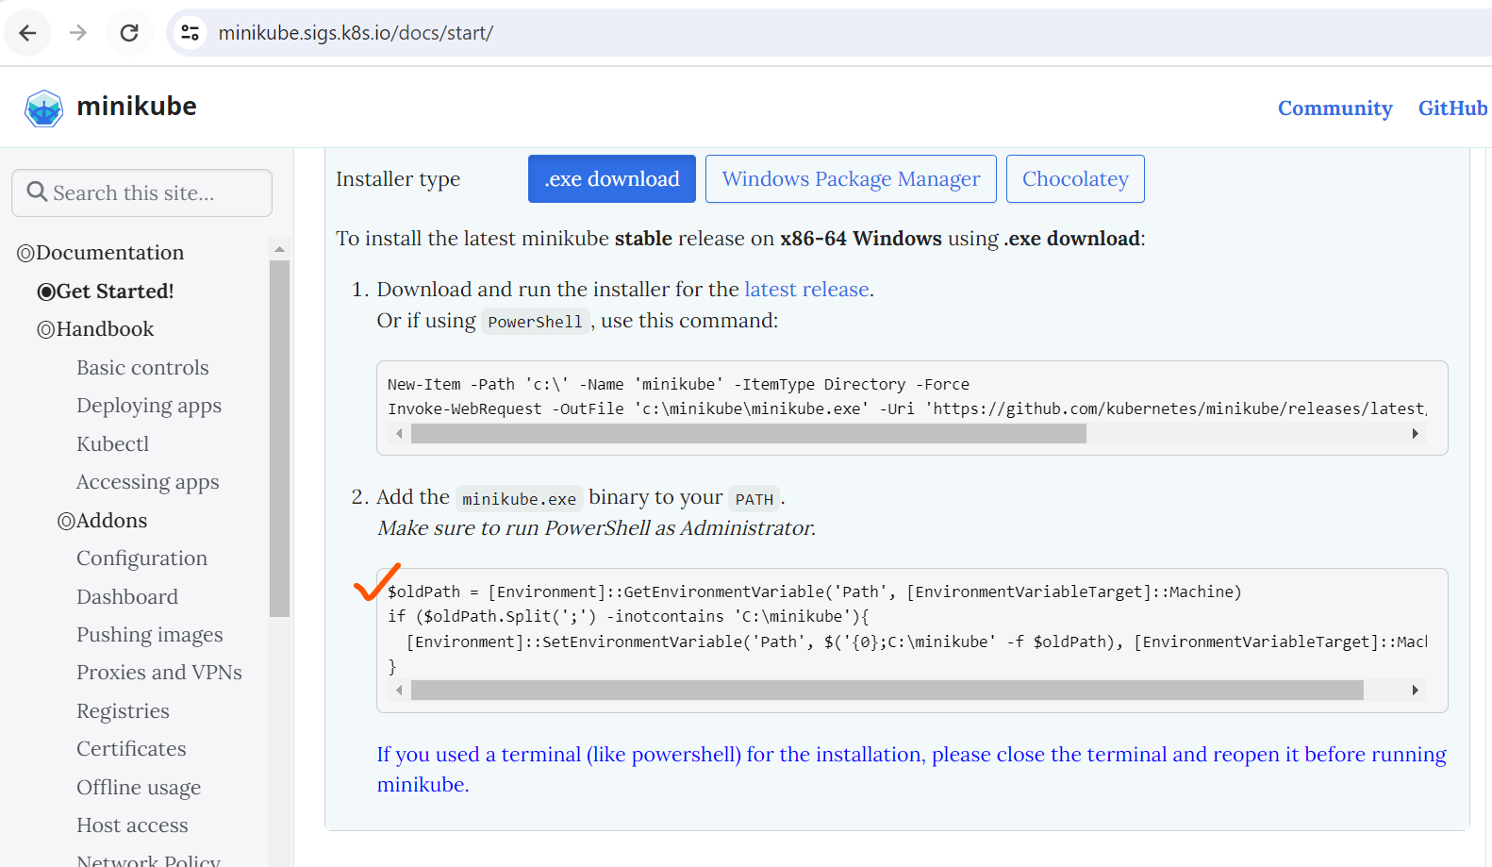  
  
# $oldPath = [Environment]::GetEnvironmentVariable('Path', [EnvironmentVariableTarget]::Machine)

if ($oldPath.Split(';') -inotcontains 'C:\minikube'){

[Environment]::SetEnvironmentVariable('Path', $('{0};C:\minikube' -f $oldPath), [EnvironmentVariableTarget]::Machine)

}  
  
# minikube start  
  
#When we get the host server issues / Need to execute the below commands  
  
# Docker context list -> To check the docker host / will get the docker host name by executing these commands  
  
  
# Docker contest use contest name (desktop-linux) -> For use the docker host run this command / Check host name above pic example  
To run the docker host use this command  
# minikube start --driver=docker

#After the installation if the master and worker nodes are not working use this commands  
  
Like this error  
  
kubeadm reset

kubeadm init

swapoff -a  
  
  
  
Flannel installation GitHub Path -> https://github.com/flannel-io/flannel